**The design and assembly of a soldering station**

|  |  |
| --- | --- |
| Author | Michiel Parthoens |

Content

Introduction 1

Material and methods 2

Results 4

Design 4

Extra’s 5

Functionality 5

Interface 6

Discussion 7

Reference list 8

# Introduction

A soldering station is a device or tool for making reliable electrical connections by melting solder that connects two metals. The device has a seven-segment display to display the current temperature of the soldering iron. It also has a rotary encoder to change that value. The design and assembly is based upon the 2105EL soldering station by Elektor [1]. This note covers the materials and methods used. Chapter 3 describes the results of the designing and assembly process. In Chapter 5 the process will be discussed, any difficulties or flaws will be described. Lastly there is a reference list added to this application note.

# Material and methods

1. **Materials:**

To create the solder station, a variety of hardware and software components are used. “Altium designer” is the software that is used for designing the pcb. The design of the case is done in “Inventor”. The “Cura slicer” is used to turn the 3D design of the case into an executable G-code for a 3D printer, in this case a “tevo tornado”.

For the hardware, different components are used like semiconductors, capacitors, resistors, relays, inductors… In the 2105EL solder station there were a lot of components that were “through hole”. This takes up a lot of space in this design of the “printed circuit board” (pcb) so mostly “surface mounted devices” (SMD) were used.

During the design and production process, there were several materials that were not useful. For example: “Several different types of soldering irons didn’t have the required needs for our soldering station”. Additionally, some soldering tips where not compatible with the soldering iron.

“A Bill of Materials” (BOM) is provided below, including the materials used, their prices, supplier names, and delivery dates:

|  |  |  |  |
| --- | --- | --- | --- |
| Item | Price (€) | Supplier | Delivery Date |
| Resistors | 0,08 | Mouser | 19/04/2023 |
| Inductors | 0,12 | lcsc | 19/04/2023 |
| Capacitors | 0,11 | lcsc | 19/04/2023 |
| Semiconductors | 0,13 | Mouser | 19/04/2023 |
| Toroidal transfo | 36,75 | Gotron | 02/06/2023 |
| PLA filament | 20,50 | 1233D | 01/06/2023 |
| Rotary encoder | 3,30 | Mouser | 19/04/2023 |
| 7-segment | 4,50 | Mouser | 22/05/2023 |
| fuses | 6,00 | Gotron | 02/06/2023 |
| Atmega | 2,30 | Mouser | 22/05/2023 |
| Ic’s | 2,60 | lcsc | 19/04/2023 |

Table 1

Components that are not listed in this list were still used. Most of the components came from the leftovers from other projects.

1. **Methods:**

To create the solder station, a step-by-step design, production, and testing process was followed. The schematic representation of this process is provided below:

There are several steps that need to be followed for designing a functioning soldering station. Firstly, information needs to be gathered about the parts that will be used. “Footprints” are needed from each component. The footprint of a component contains the physical outlay of its terminals. Electronic symbols are the second thing that come with searching for the right component. These symbols are needed to make an electrical schematic. All this info can be found in datasheets provided by the manufacturer. After all the right parts are acquired, the pcb layout is designed. While designing the pcb taking in account the shape of the case is crucial. If the case has a special design the use of rectangular boards may no longer be possible. Once the pcb is finished it can be sent to a manufacturer which makes them.

The next step is to design a case in “Inventor”. When the 3D model is finished it can be exported as a STL file. This file then goes in a slicer software, in this case “Cura”. In “Cura” the desired temperature settings are put in and the G code is generated. Before printing the case, the printer needs to be prepped. There are several methods on doing this but in this case the print bed was first cleaned and then sprayed with an adhesive.

Once the manufacturer has made the pcb. The components can be assembled. There are 2 different methods used to solder the components onto the pcb. The first one is meant for SMD components. It involves putting a soldering past on the pads of the pcb which are meant for SMD components with a screen. Then the components are placed on their corresponding position on the pcb. To melt the solder paste, the entire pcb goes into an oven. The second method is soldering the connections. This method is used for the through hole components.

Figure 1

Figure 2

When every component is mounted on the pcb the testing procedure is started. The first test is making sure there aren’t any short circuits. This is test is done with a multimeter.

Throughout the design, production, and testing process, it was ensured that the mechanical design was suitable for our needs. A sturdy and ergonomic case was created that would protect the pcb and provide comfortable use for extended periods.

# Results

## Design

The design of the soldering station is based upon a retro gas station. The holder for the soldering iron sits inbetween the two gas pumps. The parts for the case were not all printed due to problems with the heating elements of the 3D-printer. The parts that were printed still had imperfections such as layer seams. To dispose of these imperfections, aceton was rubbed on the surface and then later washed of. This melts the outer layer of the PLA to give it a smooth finish.

Figure 3

### Extra’s

Within the design of the case extra holes and slots are provided for further use. This allows the user to add more electronics like lights to there station. All the unused pins of the processor can be used to support these electronics. The pins that are unused have there own headers installed on the pcb for further use.

Figure 4

## Functionality

The power supply of the new soldering station is equipped with a single toroidal transformer (2 x 12 V, 60 VA) that efficiently delivers electrical power. In addition to its primary function, the prescribed type of transformer specified in the parts list offers two extra primary windings. These secondary windings can be utilized to provide an additional input or output on the display board, enhancing the versatility and functionality of the soldering station.

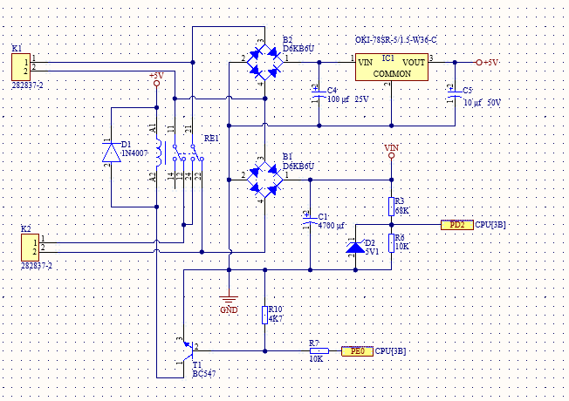

Figure 5

For the interface between the soldering station and the iron there are 2 separate opamps to measure the temperature. One is for type-c and the other for type-k thermocouples. Depending on which type is in use a different input will be used on the processor. The processor needs 750 milliseconds to obtain the temperature from the sensor. After which the processor will check if the iron’s temperature is the same as the set temperature. If not, it will start heating up the soldering iron to the desired temperature and then wait one second before restarting the cycle.

Figure 6

### Interface

The interface of the soldering iron consists of 2 parts: a rotary encoder with a push button and a four digit seven segment display. The rotation encoder is cleverly managed through a routine triggered by a timer interrupt. At intervals of 250 µs, the system reads the pins connected to the rotation encoder, extracting information about the rotation direction from the previous four pin states. It is worth noting that the rotation encoder, being a mechanical device, may introduce some irregularities in the form of fluctuations when rotated, thereby causing inherent “noise” in the input signals [1]. To mitigate this challenge, a combination of three RC low-pass filters and software-based techniques are employed to suppress and filter out the noise, ensuring accurate and reliable operation. Equally noteworthy is the inclusion of the push button integrated within the rotation encoder. This button, entwined within the same functional logic. It also uses an interrupt of 250 µs to check the state of the button.

### 

# Discussion

During the design process there were two major concerns. There was a problem with the auto routing tool in the Altium designer software. Because of this the pcb is routed by hand and therefore bigger then normal. This problem can easily be solved if the time management around the project was better regulated.

Secondly there is the problem of printing the entire case at once. This problem was solved by designing multiple smaller components that then can be put together to form the case. By doing this there is also the advantage of less waste. By reducing the print time there is a smaller chance of failures occurring.

During the Assembly of the pcb 4 major issues occurred. The first one being not having enough parts, due to not storing them incorrectly some parts got lost. Instead of keeping components in a plastic bag on a desk sort them into bins and store them somewhere safe. It is also recommended to buy extra parts in case a component broke.

The second problem involves surface mounted devices that came lose. This is due to bad screening of the pcb before putting it in an oven.

The last problem was a faulty footprint of one of the components. The holes provided in the footprint were too small for the leads of the component. This was solved by adding plugs to the holes that rounded up into a bigger diameter for the leads.

Overall, the project could have gone a lot better. Mostly due to poor time management and broken equipment.

# Reference list

[1] J. Nickel, Elektor magazine 665, Susteren Nederland.